## PROGRAM DEFINITION

|  |
| --- |
|  |
| * Program untuk Setting PM System Parameter |

## RELATED TABLES

|  |  |
| --- | --- |
|  | **Access** |
| * PMM_SYSTEM_PARAM * PMM_SYSTEM_PARAM_UTILITIES | * RW |

## ROLES

|  |  |
| --- | --- |
|  | **Test** |
| * User yang mempunyai akses ke program |  |

## MAIN FORM

### USER INTERFACE

### [CR01]

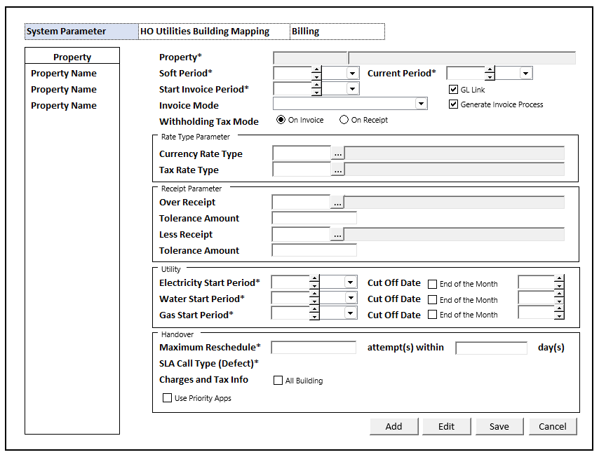

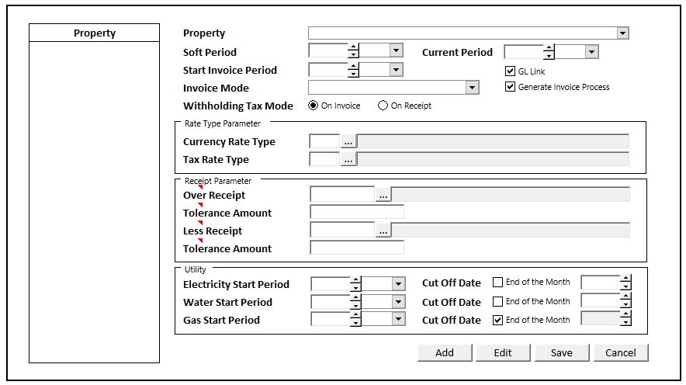

#### INITIAL VERSION

#### 

|  |  |
| --- | --- |
|  | **Test** |
| * Set VAR_COMPANY_ID = Login User’s Company ID * Set VAR_USER_ID = Login User ID * Set VAR_LANGUAGE_ID = Login User’s Language ID * **[CR01]**   ~~Get Property List to Combobox Property [PROPERTY_LIST]:~~  ~~EXEC RSP_GS_GET_PROPERTY_LIST ‘VAR_CCOMPANY_ID’, ‘VAR_USER_ID’~~  ~~Set return into binding source Combobox Property~~   * **[CR01]**   Get Property List to Grid Property [PROPERTY_LIST]:  EXEC RSP_GS_GET_PROPERTY_LIST ‘VAR_CCOMPANY_ID’, ‘VAR_USER_ID’  Set first item as VAR_SELECTED_PROPERTY **[CR01]**   * Jalankan RSP_GS_GET_PERIOD_YEAR_RANGE dengan parameter, simpan hasil ke VAR_GSM_PERIOD   + VAR_COMPANY_ID   + ‘’ (Empty String)   + ‘’ (Empty String) * **[CR01]**   ~~Jalankan RSP_PM_GET_SYSTEM_PARAMETER_LIST dengan parameter:~~   * + ~~VAR_COMPANY_ID~~   + ~~VAR_USER_ID~~   ~~Set Return to Grid, Display only CPROPERTY_NAME on Grid. Default Current to First Record~~  Jika Current Property pada Grid isnot nothing : lakukan DISPLAY PROCESS |  |

### TAB DEFINITION [CR01]

|  |  |  |
| --- | --- | --- |
| **Tab Name** | **Action** | **Enabled** |
| System Parameter  **[CR01]** | Go to TAB SYSTEM PARAMETER | * + NOT on CRUD Mode |
| Utilities Building Mapping  **[CR01]** | Go to TAB UTILITIES BUILDING MAPPING | * + NOT on CRUD Mode   + Selected System Param is not EMPTY |

### BUTTON DEFINITION

|  |  |
| --- | --- |
| **Button Name** | **Action** |
| Add | Untuk masuk pada Add Mode (ADD PROCESS) |
| Edit | Untuk masuk pada Edit Mode (EDIT PROCESS |
| Save | Jalankan SAVE PROCESS |
| Cancel | Untuk Cancel Add atau Edit Mode dan kembali ke Display Mode |

### DISPLAY PROCESS

|  |  |
| --- | --- |
|  | **Test** |
| * Load Selected Property Data   EXEC RSP_PM_GET_SYSTEM_PARAMETER_DETAIL dengan parameter, simpan hasil ke VAR_SYSTEM_PARAM:   * + VAR_COMPANY_ID   + VAR_SELECTED_PROPERTY   + VAR_USER_ID   Set VAR_SYSTEM_PARAM ke binding source Form. |  |

#### FIELD DEFINITION

|  |  |  |  |
| --- | --- | --- | --- |
| **Name** | **Field** | **Type** | **Validation** |
| ~~Property~~  **[CR01]** | ~~Set Value : CPROPERTY_ID  Set Display : CPROPERTY_NAME~~  ~~As Parameter: CPROPERTY_ID~~ | ~~Combobox~~ | * ~~Mandatory~~ * ~~Get DataSource from [PROPERTY_LIST]~~ * ~~Add or Edit Mode: IF Combobox Empty~~   + ~~Display message “Please select property !”~~ |
| Property  **[CR01]** | CPROPERTY_ID  CPROPERTY_NAME | Textbox | * Mandatory * Always Disabled |
| Soft Period Year | As Parameter: CSOFT_PERIOD_YEAR  Set Display : LEFT(CSOFT_PERIOD,4) | Spinner   * Minimum Value = VAR_GSM_PERIOD.IMIN_YEAR * Minimum Value = VAR_GSM_PERIOD.IMAX_YEAR * Stepping value = 1   Set Default when Add = Year.Today | * Mandatory * Enabled = VAR_SYSTEM_PARAM.LENABLED_PERIOD **[CR01]** * Add or Edit Mode: IF Combobox Empty   + Display message “Please select soft period !” |
| Soft Period Month | As Parameter: CSOFT_PERIOD_MONTH  Set Display : RIGHT(CSOFT_PERIOD,2) | Combobox  Isi combobox dengan RSP_GS_GET_PERIOD_DT_LIST dengan parameter:   * VAR_COMPANY_ID * Year.Today   Set Item Code=CPERIOD_NO  Set Item Name=CPERIOD_NO | * Mandatory * Enabled = VAR_SYSTEM_PARAM.LENABLED_PERIOD **[CR01]** * Default Value = Month.Today * Add or Edit Mode: IF Combobox Empty   + Display message “Please select soft period !” |
| Current Period Year | As Parameter: CCURRENT_PERIOD_YEAR  Set Display : LEFT(CCURRENT_PERIOD,4) | Spinner   * Minimum Value = VAR_GSM_PERIOD.IMIN_YEAR * Minimum Value = VAR_GSM_PERIOD.IMAX_YEAR * Stepping value = 1   Set Default when Add = Year.Today | * Mandatory * Enabled = VAR_SYSTEM_PARAM.LENABLED_PERIOD **[CR01]** * Add or Edit Mode: IF Combobox Empty * Display message “Please select soft period !” |
| Current Period Month | As Parameter: CCURRENT_PERIOD_MONTH  Set Display : RIGHT(CCURRENT_PERIOD,2) | Combobox  Isi combobox dengan RSP_GS_GET_PERIOD_DT_LIST dengan parameter:   * VAR_COMPANY_ID * Year.Today   Set Item Code=CPERIOD_NO  Set Item Name=CPERIOD_NO | * Mandatory * Enabled = VAR_SYSTEM_PARAM.LENABLED_PERIOD **[CR01]** * Default Value = Month.Today * Add or Edit Mode: IF Combobox Empty * Display message “Please select current period !” |
| Start Invoice Period Year | As Parameter: CINV_PERIOD_YEAR  Set Display : LEFT(CINV_PRD,4) | Spinner   * Minimum Value = VAR_GSM_PERIOD.IMIN_YEAR * Minimum Value = VAR_GSM_PERIOD.IMAX_YEAR * Stepping value = 1   Set Default when Add = Year.Today | * Mandatory * Enabled = VAR_SYSTEM_PARAM.LENABLED_PERIOD **[CR01]** * Add or Edit Mode: IF Combobox Empty * Display message “Please select start invoice period !” |
| Start Invoice Month | As Parameter: CINV_PERIOD_MONTH  Set Display : RIGHT(CINV_PRD,2) | Combobox  Isi combobox dengan RSP_GS_GET_PERIOD_DT_LIST dengan parameter:   * VAR_COMPANY_ID * Year.Today   Set Item Code=CPERIOD_NO  Set Item Name=CPERIOD_NO | * Mandatory * Enabled = VAR_SYSTEM_PARAM.LENABLED_PERIOD **[CR01]** * Default Value = Month.Today * Add or Edit Mode: IF Combobox Empty   + Display message “Please select start invoice period !” |
| GL Link  **[CR01]** | * LGLLINK | Checkbox | * Default Value = False |
| Generate Invoice Process  **[CR01]** | * LINV_PROCESS_FLAG | Checkbox | * Default Value = False |
| Invoice Mode | CINVOICE_MODE | Combobox  Isi combobox dengan RSP_GS_GET_GSB_CODE_LIST dengan parameter:   * ‘BIMASAKTI’ * VAR_COMPANY_ID * ‘_BS_GENERATE_INVOICE_MODE’ * VAR_LANG_ID * ‘’   Set Item Code=CCODE  Set Item Name=CNAME | * Default Value = Invoice |
| Withholding Tax Mode | CWHT_MODE  As Parameter  IF On Receipt ischeked = True THEN  CWHT_MODE = ‘R’ ELSE  CWHT_MODE = ‘I’ | Radio button  IF CWHT_MODE = ‘R’ THEN  Radio choose: On Receipt  ELSE  Radio choose: On Invoice | * Default Value When Add = On Invoice |
| Currency Rate Type | CCUR_RATE_TYPE_CODE CCUR_RATE_TYPE_DESC  Value: CCUR_RATE_TYPE_CODE | Textbox & Button Lookup | * Currency Rate Desc always disabled * Currency Rate Code & button lookup always enabled(add & edit) * Do Lookup GSL00800 CURRENCY RATE TYPE LOOKUP, Parameter:   + VAR_COMPANY_ID   + VAR_USER_ID * Set CCUR_RATE_TYPE_CODE = lookup.CRATETYPE_CODE * Set CCUR_RATE_TYPE_DESC = lookup. CRATETYPE_DESCRIPTION |
| Tax Rate Type | CTAX_RATE_TYPE_CODE CTAX_RATE_TYPE_DESC  Value: CTAX_RATE_TYPE_CODE | Textbox & Button Lookup | * Tax Rate Desc always disabled * Tax Rate Code & button lookup always enabled (add & edit) * Do Lookup GSL00100 TAX RATE TYPE LOOKUP, Parameter:   + VAR_COMPANY_ID   + VAR_USER_ID * Set CTAX_RATE_TYPE_CODE = lookup.CTAX_ID * Set CTAX_RATE_TYPE_DESC = lookup.CTAX_NAME |
| Over Receipt | COVER_RECEIPT  COVER_RECEIPT_DESC  Value :  COVER_RECEIPT | Textbox & Button Lookup | * Over Receipt Desc always disabled * Over Receipt & button lookup always enabled (add & edit) * Do Lookup GSL01400 OTHER CHARGES LOOKUP, Parameter:   + VAR_COMPANY_ID   + Selected Combobox CPROPERTY_ID   + ‘**A**’ * Set COVER_RECEIPT = lookup. * Set COVER_RECEIPT_DESC = lookup. |
| Over Tolerance Amount | NOVER_TOLERANCE_AMOUNT | Spinner | * Decimal Places 2 |
| Less Receipt | CLESS_RECEIPT  CLESS_RECEIPT_DESC  Value :  CLESS_RECEIPT | Textbox & Button Lookup | * Less Receipt Desc always disabled * Less Receipt & button lookup always enabled (add & edit) * Do Lookup GSL01400 OTHER CHARGES LOOKUP, Parameter:   + VAR_COMPANY_ID   + Selected Combobox CPROPERTY_ID   + ‘**D**’ * Set CLESS_RECEIPT = lookup. * Set CLESS_RECEIPT_DESC = lookup. |
| Less Tolerance Amount | NLESS_TOLERANCE_AMOUNT | Spinner | Decimal Places 2 |
| Electricity Start Period Year | As Parameter: CELECTRIC_PERIOD_YEAR  Set Display : LEFT(CELECTRIC_PERIOD,4) | Spinner   * Minimum Value = VAR_GSM_PERIOD.IMIN_YEAR * Minimum Value = VAR_GSM_PERIOD.IMAX_YEAR * Stepping value = 1   Set Default when Add = Year.Today | * Mandatory * Enabled = VAR_SYSTEM_PARAM. LENABLED_UTILITY_PERIOD **[CR01]** * Add or Edit Mode: IF Combobox Empty * Display message “Please select electricity start period !” |
| Electricity Start Period Month | As Parameter: CELECTRIC_PERIOD_MONTH  Set Display : RIGHT(CELECTRIC_PERIOD,2) | Combobox  Isi combobox dengan RSP_GS_GET_PERIOD_DT_LIST dengan parameter:   * VAR_COMPANY_ID * Year.Today   Set Item Code=CPERIOD_NO  Set Item Name=CPERIOD_NO | * Mandatory * Enabled = VAR_SYSTEM_PARAM. LENABLED_UTILITY_PERIOD **[CR01]** * Default Value = Month.Today * Add or Edit Mode: IF Combobox Empty * Display message “Please select electricity start period !” |
| Water Start Period Year | As Parameter: CWATER_PERIOD_YEAR  Set Display : LEFT(CWATER_PERIOD,4) | Spinner   * Minimum Value = VAR_GSM_PERIOD.IMIN_YEAR * Minimum Value = VAR_GSM_PERIOD.IMAX_YEAR * Stepping value = 1   Set Default when Add = Year.Today | * Mandatory * Enabled = VAR_SYSTEM_PARAM. LENABLED_UTILITY_PERIOD **[CR01]** * Add or Edit Mode: IF Combobox Empty * Display message “Please select Water start period !” |
| Water Start Period Month | As Parameter: CWATER_PERIOD_MONTH  Set Display : RIGHT(CWATER_PERIOD,2) | Combobox  Isi combobox dengan RSP_GS_GET_PERIOD_DT_LIST dengan parameter:   * VAR_COMPANY_ID * Year.Today   Set Item Code=CPERIOD_NO  Set Item Name=CPERIOD_NO | * Mandatory * Enabled = VAR_SYSTEM_PARAM. LENABLED_UTILITY_PERIOD **[CR01]** * Default Value = Month.Today * Add or Edit Mode: IF Combobox Empty * Display message “Please select Water start period !” |
| Gas Start Period Year | As Parameter: CGAS_PERIOD_YEAR  Set Display : LEFT(CGAS_PERIOD,4) | Spinner   * Minimum Value = VAR_GSM_PERIOD.IMIN_YEAR * Minimum Value = VAR_GSM_PERIOD.IMAX_YEAR * Stepping value = 1   Set Default when Add = Year.Today | * Mandatory * Enabled = VAR_SYSTEM_PARAM. LENABLED_UTILITY_PERIOD **[CR01]** * Add or Edit Mode: IF Combobox Empty * Display message “Please select Gas start period !” |
| Gas Start Period Month | As Parameter: CGAS_PERIOD_MONTH  Set Display : RIGHT(CGAS_PERIOD,2) | Combobox  Isi combobox dengan RSP_GS_GET_PERIOD_DT_LIST dengan parameter:   * VAR_COMPANY_ID * Year.Today   Set Item Code=CPERIOD_NO  Set Item Name=CPERIOD_NO | * Mandatory * Enabled = VAR_SYSTEM_PARAM. LENABLED_UTILITY_PERIOD **[CR01]** * Default Value = Month.Today * Add or Edit Mode: IF Combobox Empty   Display message “Please select Gas start period !” |
| Electricity Cut Off Date | LELECTRIC_END_MONTH | Checkbox | * Default Value = unchecked * IF Checked THEN   Disabled Electric Date Spinner on the right  Else  Enabled Electric Date Spinner on the right |
| Water Cut Off Date | LWATER_END_MONTH | Checkbox | * Default Value = unchecked * IF Checked THEN   Disabled Water Date Spinner on the right  Else  Enabled Water Date Spinner on the right |
| Gas Cut Off Date | LGAS_END_MONTH | Checkbox | * Default Value = unchecked * IF Checked THEN   Disabled Gas Date Spinner on the right  Else  Enabled Gas Date Spinner on the right |
| Electricity Cut Off Date Spinner | CELECTRIC_DATE | Spinner  Min: 1 Max: 31 | * Default Value = unchecked * Enabled When Checkbox Electric End of Month = True (add or edit) * Convert to Char(2) * Ex: 3 => ‘03’ |
| Water Cut Off Date Spinner | CWATER_DATE | Spinner Min: 1  Max: 31 | * Default Value = unchecked * Enabled When Checkbox water End of Month = True (add or edit) * Convert to Char(2) * Ex: 3 => ‘03’ |
| Gas Cut Off Date Spinner | CGAS_DATE | Spinner  Min: 1  Max: 31 | * Default Value = unchecked * Enabled When Checkbox GasEnd of Month = True (add or edit) * Convert to Char(2) * Ex: 3 => ‘03’ |
| Maximum Reschedule Attempts  **[CR01]** | IMAX_ATTEMPTS  Set Display:  attempt(s) within | Spinner  Min: 1 | * Mandatory * No arrows * Decimal Places 0 |
| Maximum Reschedule Days  **[CR01]** | IMAX_DAYS  Set Display:  day(s) | Spinner  Min: 1 | * Mandatory * No arrows * Decimal Places 0 |
| SLA Call Type (Defect)  **[CR01]** | CCALL_TYPE_ID  CCALL_TYPE_NAME  Value :  CCALL_TYPE_ID | Textbox & Button Lookup | * SLA Call Type Name always disabled * SLA Call Type ID & button lookup always enabled (add & edit) * Do OnLostFocus on SLA Call Type ID Textbox calling **Lookup PML01600 – SLA Call Type**, Parameter:   + VAR_SELECTED_PROPERTY. CPROPERTY_ID   + CCALL_TYPE_ID * Do Lookup **PML01600 – SLA Call Type**, Parameter:   + VAR_SELECTED_PROPERTY. CPROPERTY_ID   + ‘’ * Set CCALL_TYPE_ID = Lookup.CCALL_TYPE_ID * Set CCALL_TYPE_NAME = Lookup.CCALL_TYPE_NAME |
| Charges and Tax Info  **[CR01]** | LALL_BUILDING  Set Display:  All Building | Checkbox | * Default Value = checked |
| Use Priority Apps  **[CR01]** | LPRIORITY  Set Display:  Use Priority Apps | Checkbox | * Default Value = unchecked |

### ADD PROCESS

|  |  |
| --- | --- |
|  | **Test** |
| * Set **VAR_SAVE_MODE** = NEW * Enabled fields: All Field Except: “Property Id & Name”, **[CR01]** "All lookup description” * Set focus to column: ~~"Combobox Property Id"~~ “Soft Period Year Spinner” **[CR01]** |  |
| * Proses   + - * + “Save” 🡪 Go to SAVE PROCESS         + “Cancel”🡪 Go to DISPLAY PROCESS |  |

### EDIT PROCESS

|  |  |
| --- | --- |
|  | **Test** |
| * Set **VAR_SAVE_MODE** = EDIT * Enabled fields : All Field Except: “Property Id & Name”, **[CR01]** "All lookup description” * Set focus to column: ~~"Combobox Property Id"~~ “Soft Period Year Spinner” **[CR01]** |  |
| * Proses   + - * + “Save” 🡪 Go to SAVE PROCESS         + “Cancel”🡪 Go to DISPLAY PROCESS |  |

### SAVE PROCESS

###### VALIDATION

|  |  |  |
| --- | --- | --- |
| **Field** | **Condition** | **Validation Message** |
| Property | Empty | Please select Property ! |
| Soft Period **[CR01]** | Soft Period Year OR Soft Period Month is Empty | Please fill Soft Period! |
| Current Period **[CR01]** | Current Period Year OR Current Period Month is Empty | Please fill Current Period! |
| Start Invoice Period **[CR01]** | Start Invoice Period Year OR Start Invoice Period Month is Empty | Please fill Start Invoice Period! |
| Electricity Start Period  **[CR01]** | Electricity Start Period Year OR Electricity Start Period Month is Empty | Please fill Electricity Start Period! |
| Electricity Cut Off Date  **[CR01]** | Electricity End of The Month is FALSE and Electricity Cut Off Date Spinner is Empty | Please fill Electricity Cut Off Date! |
| Water Start Period  **[CR01]** | Water Start Period Year OR Water Start Period Month is Empty | Please fill Water Start Period! |
| Water Cut Off Date  **[CR01]** | Water End of The Month is FALSE and Water Cut Off Date Spinner is Empty | Please fill Water Cut Off Date! |
| Gas Start Period  **[CR01]** | Gas Start Period Year OR Gas Start Period Month is Empty | Please fill Gas Start Period! |
| Gas Cut Off Date  **[CR01]** | Gas End of The Month is FALSE and Gas Cut Off Date Spinner is Empty | Please fill Gas Cut Off Date! |
| Maximum Reschedule Days  **[CR01]** | Maximum Reschedule Days (IMAX_DAYS) is Empty or 0 | Please fill Maximum Reschedule Days! |
| Maximum Reschedule Attempts  **[CR01]** | Maximum Reschedule Attempts (IMAX_ATTEMPTS) is Empty or 0 | Please fill Maximum Reschedule Attempts! |
| SLA Call Type (Defect)  **[CR01]** | SLA Call Type ID is Empty | Please choose SLA Call Type (Defect)! |

#### ACTION

|  |
| --- |
|  |
| * Jalankan RSP_PM_MAINTAIN_SYSTEM_PARAMETER dengan parameter   + - VAR_COMPANY_ID     - Selected CPROPERTY_ID     - Selected CSOFT_PERIOD_YEAR + Selected CSOFT_PERIOD_MONTH (yyyymm)     - Selected CCURRENT_PERIOD_YEAR + Selected CCURRENT_PERIOD_MONTH (yyyymm)     - Selected CINV_PERIOD_YEAR + Selected CINV_PERIOD_MONTH (yyyymm)     - Selected LGLLINK **[CR01]**     - Selected LINV_PROCESS_FLAG **[CR01]**     - Selected CINVOICE_MODE     - Selected CWHT_MODE     - Selected CCUR_RATE_TYPE_CODE     - Selected CTAX_RATE_TYPE_CODE     - Selected COVER_RECEIPT     - Selected NOVER_TOLERANCE_AMOUNT     - Selected CLESS_RECEIPT     - Selected NLESS_TOLERANCE_AMOUNT     - Selected CELECTRIC_PERIOD_YEAR + Selected CELECTRIC_PERIOD_MONTH(yyyymm)     - Selected CWATER_PERIOD_YEAR + Selected CWATER_PERIOD_MONTH(yyyymm)     - Selected CGAS_PERIOD_YEAR + Selected CGAS_PERIOD_MONTH(yyyymm)     - Selected LELECTRIC_END_MONTH     - Selected LWATER_END_MONTH     - Selected LGAS_END_MONTH     - Selected CELECTRIC_DATE     - Selected CWATER_DATE     - Selected CGAS_DATE     - Selected LALL_BUILDING **[CR01]**     - Selected IMAX_DAYS **[CR01]**     - Selected IMAX_ATTEMPTS **[CR01]**     - Selected CCALL_TYPE_ID **[CR01]**     - Selected LPRIORITY **[CR01]**     - VAR_SAVE_MODE     - VAR_USER_ID |

## TAB HO UTILITIES BUILDING MAPPING

### USER INTERFACE

#### [CR03]

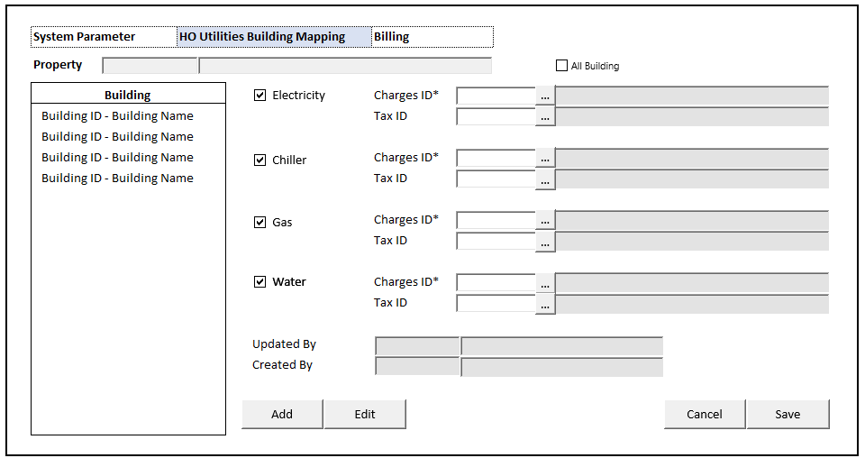

#### INITIAL VERSION

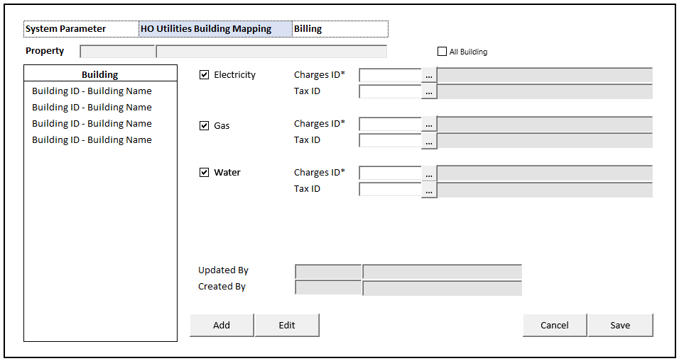

### INPUT PARAMETER

|  |  |
| --- | --- |
| **Parameter Name** | **Description** |
| PARAM_PROPERTY_ID | VAR_SELECTED_PROPERTY.CPROPERTY_ID from TAB SYSTEM PARAMETER |
| PARAM_PROPERTY_NAME | VAR_SELECTED_PROPERTY.CPROPERTY_NAME from TAB SYSTEM PARAMETER |
| PARAM_ALL_BUILDING | Selected System Param LALL_BUILDING from TAB SYSTEM PARAMETER |

### INITIAL PROCESS

|  |  |
| --- | --- |
|  | **Test** |
| * **Load Building List**   Jalankan RSP_GS_GET_BUILDING_LIST dengan parameter, simpan hasil ke VAR_BUILDING dan VAR_SELECTED_BUILDING   * + VAR_COMPANY_ID   + VAR_SELECTED_PROPERTY.CPROPERTY_ID   + VAR_USER_ID   **IF PARAM_ALL_BUILDING = FALSE**   * **Load Building Utilities**   Jalankan RSP_PM_GET_BUILDING_UTILITIES dengan parameter, simpan hasil ke VAR_UTILITIES   * + VAR_COMPANY_ID   + VAR_SELECTED_PROPERTY.CPROPERTY_ID   + VAR_SELECTED_BUILDING.CBUILDING_ID   **IF PARAM_ALL_BUILDING = TRUE**   * Set **VAR_SELECTED_BUILDING** = ‘’ * **Load Building Utilities**   Jalankan RSP_PM_GET_BUILDING_UTILITIES dengan parameter, simpan hasil ke VAR_UTILITIES   * + VAR_COMPANY_ID   + VAR_SELECTED_PROPERTY.CPROPERTY_ID   + ‘’ |  |

### BUTTON DEFINITION

|  |  |  |
| --- | --- | --- |
| **Button Name** | **Action** | **Enabled** |
| Add | Jalankan ADD NEW PROCESS | * + NOT on CRUD Mode   + VAR_UTILITIES is EMPTY |
| Edit | Jalankan EDIT PROCESS | * + NOT on CRUD Mode   + VAR_UTILITIES is not EMPTY |
| Cancel | Go to DISPLAY PROCESS | * + On CRUD Mode |
| Save | Jalankan SAVE & VALIDATION PROCESS | * + On CRUD Mode |

### ROLES

|  |  |
| --- | --- |
|  | **Test** |
| * User yg punya akses ke program |  |

### DISPLAY PROCESS

#### FIELD DEFINITION

|  |  |  |  |
| --- | --- | --- | --- |
| **Name** | **Field** | **Type** | **Validation** |
| Property | PARAM_PROPERTY_ID | Textbox, Disabled |  |
|  | PARAM_PROPERTY_NAME | Textbox, Disabled |  |
| All Building | PARAM_ALL_BUILDING | Checkbox, Disabled |  |
| **Building List Grid** |  | **Data:** VAR_BUILDING | Allow: -  ViewOnly  Enabled:  All Building is **UNCHECKED**  On Selected Changed,  Set **VAR_SELECTED_BUILDING** = Selected row data  **Load Building Utilities**  Jalankan RSP_PM_GET_BUILDING_UTILITIES dengan parameter:   * + VAR_COMPANY_ID   + VAR_SELECTED_PROPERTY.CPROPERTY_ID   + VAR_SELECTED_BUILDING.CBUILDING_ID   Simpan hasil ke **VAR_UTILITIES** |
| Building | CBUILDING_ID – CBUILDING_NAME | Textbox, Disabled |  |

|  |  |  |  |
| --- | --- | --- | --- |
| **Display Form** |  | **Data**: VAR_UTILITIES |  |
| Electricity | LELECTRICITY | Checkbox, Disabled | Enabled:  on ADD & EDIT  On Unchecked, delete:  CELECTRICITY_CHARGES_ID, CELECTRICITY_CHARGES_NAME, LELECTRICITY_CHARGES_TAXABLE,  CELECTRICITY_TAX_ID,  CELECTRICITY_TAX_NAME |
| Charges ID | CELECTRICITY_CHARGES_ID | Textbox, Disabled, Required | Enabled:  on ADD & EDIT  Electricity is CHECKED  On Lost Focus  Go to 🡪 CHARGES ID LOOKUP PROCESS  On value change, update:  CELECTRICITY_CHARGES_ID, CELECTRICITY_CHARGES_NAME, LELECTRICITY_CHARGES_TAXABLE |
| Lookup, Disabled | Enabled:  on ADD & EDIT  Electricity is CHECKED  On Lookup Button clicked:  Go to 🡪 CHARGES ID LOOKUP PROCESS  On value change, update:  CELECTRICITY_CHARGES_ID, CELECTRICITY_CHARGES_NAME, LELECTRICITY_CHARGES_TAXABLE |
| CELECTRICITY_CHARGES_NAME | Textbox, Disabled |  |
| LELECTRICITY_CHARGES_TAXABLE | Hidden | On value change,  If FALSE, delete:  CELECTRICITY_TAX_ID, CELECTRICITY_TAX_NAME |
| Tax ID | CELECTRICITY_TAX_ID | Textbox, Disabled, Required | Enabled:  on ADD & EDIT  Electricity is CHECKED  LELECTRICITY_CHARGES_TAXABLE is TRUE  On Lost Focus  Go to 🡪 TAX ID LOOKUP PROCESS  On value change, update:  CELECTRICITY_TAX_ID, CELECTRICITY_TAX_NAME |
| Lookup, Disabled | Enabled:  on ADD & EDIT  Electricity is CHECKED  LELECTRICITY_CHARGES_TAXABLE is TRUE  On Lookup Button clicked:  Go to 🡪 TAX ID LOOKUP PROCESS  On value change, update:  CELECTRICITY_TAX_ID, CELECTRICITY_TAX_NAME |
| CELECTRICITY_TAX_NAME | Textbox, Disabled |  |
|  |  |  |  |
| Chiller  **[CR03]** | LCHILLER | Checkbox, Disabled | Enabled:  on ADD & EDIT  On Unchecked, delete:  CCHILLER_CHARGES_ID, CCHILLER_CHARGES_NAME, LCHILLER_CHARGES_TAXABLE,  CCHILLER_TAX_ID,  CCHILLER_TAX_NAME |
| Charges ID  **[CR03]** | CCHILLER_CHARGES_ID | Textbox, Disabled, Required | Enabled:  on ADD & EDIT  Chiller is CHECKED  On Lost Focus  Go to 🡪 CHARGES ID LOOKUP PROCESS  On value change, update:  CCHILLER_CHARGES_ID, CCHILLER_CHARGES_NAME, LCHILLER_CHARGES_TAXABLE |
| Lookup, Disabled | Enabled:  on ADD & EDIT  Chiller is CHECKED  On Lookup Button clicked:  Go to 🡪 CHARGES ID LOOKUP PROCESS  On value change, update:  CCHILLER_CHARGES_ID, CCHILLER_CHARGES_NAME, LCHILLER_CHARGES_TAXABLE |
| CCHILLER_CHARGES_NAME | Textbox, Disabled |  |
| LCHILLER_CHARGES_TAXABLE | Hidden | On value change,  If FALSE, delete:  CCHILLER_TAX_ID, CCHILLER_TAX_NAME |
| Tax ID  **[CR03]** | CCHILLER_TAX_ID | Textbox, Disabled, Required | Enabled:  on ADD & EDIT  Chiller is CHECKED  LCHILLER_CHARGES_TAXABLE is TRUE  On Lost Focus  Go to 🡪 TAX ID LOOKUP PROCESS  On value change, update:  CCHILLER_TAX_ID, CCHILLER_TAX_NAME |
| Lookup, Disabled | Enabled:  on ADD & EDIT  Chiller is CHECKED  LCHILLER_CHARGES_TAXABLE is TRUE  On Lookup Button clicked:  Go to 🡪 TAX ID LOOKUP PROCESS  On value change, update:  CCHILLER_TAX_ID, CCHILLER_TAX_NAME |
| CCHILLER_TAX_NAME | Textbox, Disabled |  |
|  |  |  |  |
| Gas | LGAS | Checkbox, Disabled | Enabled:  on ADD & EDIT  On Unchecked, delete:  CGAS_CHARGES_ID, CGAS_CHARGES_NAME, LGAS_CHARGES_TAXABLE,  CGAS_TAX_ID,  CGAS_TAX_NAME |
| Charges ID | CGAS_CHARGES_ID | Textbox, Disabled, Required | Enabled:  on ADD & EDIT  Gas is CHECKED  On Lost Focus  Go to 🡪 CHARGES ID LOOKUP PROCESS  On value change, update:  CGAS_CHARGES_ID, CGAS_CHARGES_NAME, LGAS_CHARGES_TAXABLE |
| Lookup, Disabled | Enabled:  on ADD & EDIT  Gas is CHECKED  On Lookup Button clicked:  Go to 🡪 CHARGES ID LOOKUP PROCESS  On value change, update:  CGAS_CHARGES_ID, CGAS_CHARGES_NAME, LGAS_CHARGES_TAXABLE |
| CGAS_CHARGES_NAME | Textbox, Disabled |  |
| LGAS_CHARGES_TAXABLE | Hidden | On value change,  If FALSE, delete:  CGAS_TAX_ID, CGAS_TAX_NAME |
| Tax ID | CGAS_TAX_ID | Textbox, Disabled, Required | Enabled:  on ADD & EDIT  Gas is CHECKED  LGAS_CHARGES_TAXABLE is TRUE  On Lost Focus  Go to 🡪 TAX ID LOOKUP PROCESS  On value change, update:  CGAS_TAX_ID, CGAS_TAX_NAME |
| Lookup, Disabled | Enabled:  on ADD & EDIT  Gas is CHECKED  LGAS_CHARGES_TAXABLE is TRUE  On Lookup Button clicked:  Go to 🡪 TAX ID LOOKUP PROCESS  On value change, update:  CGAS_TAX_ID, CGAS_TAX_NAME |
| CGAS_TAX_NAME | Textbox, Disabled |  |
|  |  |  |  |
| Water | LWATER | Checkbox, Disabled | Enabled:  on ADD & EDIT  On Unchecked, delete:  CWATER_CHARGES_ID, CWATER_CHARGES_NAME, LWATER_CHARGES_TAXABLE CWATER_TAX_ID,  CWATER_TAX_NAME |
| Charges ID | CWATER_CHARGES_ID | Textbox, Disabled, Required | Enabled:  on ADD & EDIT  Water is CHECKED  On Lost Focus  Go to 🡪 CHARGES ID LOOKUP PROCESS  On value change, update:  CWATER_CHARGES_ID, CWATER_CHARGES_NAME, LWATER_CHARGES_TAXABLE |
| Lookup, Disabled | Enabled:  on ADD & EDIT  Water is CHECKED  On Lookup Button clicked:  Go to 🡪 CHARGES ID LOOKUP PROCESS  On value change, update:  CWATER_CHARGES_ID, CWATER_CHARGES_NAME, LWATER_CHARGES_TAXABLE |
| CWATER_CHARGES_NAME | Textbox, Disabled |  |
| LWATER_CHARGES_TAXABLE | Hidden | On value change,  If FALSE, delete:  CWATER_TAX_ID, CWATER_TAX_NAME |
| Tax ID | CWATER_TAX_ID | Textbox, Disabled, Required | Enabled:  on ADD & EDIT  Water is CHECKED  LWATER_CHARGES_TAXABLE is TRUE  On Lost Focus  Go to 🡪 TAX ID LOOKUP PROCESS  On value change, update:  CWATER_TAX_ID, CWATER_TAX_NAME |
| Lookup, Disabled | Enabled:  on ADD & EDIT  Water is CHECKED  LWATER_CHARGES_TAXABLE is TRUE  On Lookup Button clicked:  Go to 🡪 TAX ID LOOKUP PROCESS  On value change, update:  CWATER_TAX_ID, CWATER_TAX_NAME |
| CWATER_TAX_NAME | Textbox, Disabled |  |
|  |  |  |  |
| Updated By | CUPDATE_BY | Textbox, Disabled |  |
|  | DUPDATE_DATE | DateTimePicker, Disabled |  |
| Created By | CCREATE_BY | Textbox, Disabled |  |
|  | DCREATE_DATE | DateTimePicker, Disabled |  |

### ADD NEW PROCESS

#### ACTION

|  |
| --- |
|  |
| * Set **VAR_SAVE_MODE** = ‘ADD’ * Enabled Fields: ‘Electricity’, ‘Electricity Charges ID’, ‘Electricity Tax ID’, ‘Gas’, ‘Gas Charges ID’, ‘Gas Tax ID’, ‘Water’, ‘Water Charges ID’, ‘Water Tax ID’,  ‘Chiller’, ‘Chiller Charges ID’, ‘Chiller Tax ID’ **[CR03]** * Set focus to column: ‘Electricity’ |
| * Proses:   + ‘Save’ 🡪 Go To SAVE & VALIDATION PROCESS   + ‘Cancel’ 🡪 Go To DISPLAY PROCESS |

### EDIT PROCESS

#### ACTION

|  |
| --- |
|  |
| * Set **VAR_SAVE_MODE** = ‘EDIT’ * Enabled Fields: ‘Electricity’, ‘Electricity Charges ID’, ‘Electricity Tax ID’, ‘Gas’, ‘Gas Charges ID’, ‘Gas Tax ID’, ‘Water’, ‘Water Charges ID’, ‘Water Tax ID’ ‘Chiller’, ‘Chiller Charges ID’, ‘Chiller Tax ID’ **[CR03]** * Set focus to column: ‘Electricity’ |
| * Proses:   + ‘Save’ 🡪 Go To SAVE & VALIDATION PROCESS   + ‘Cancel’ 🡪 Go To DISPLAY PROCESS |

### SAVE & VALIDATION PROCESS

#### VALIDATION

|  |  |  |
| --- | --- | --- |
| **Field** | **Condition** | **Validation Message** |
| Electricity Charges ID | Electricity is checked and Empty | Please fill Electricity Charges ID! |
| Electricity Tax ID | Electricity Charges ID is taxable and Empty | Please fill Electricity Tax ID! |
| Chiller Charges ID **[CR03]** | Chiller is checked and Empty | Please fill Chiller Charges ID! |
| Chiller Tax ID **[CR03]** | Chiller Charges ID is taxable and Empty | Please fill Chiller Tax ID! |
| Gas Charges ID | Gas is checked and Empty | Please fill Gas Charges ID! |
| Gas Tax ID | Gas Charges ID is taxable and Empty | Please fill Gas Tax ID! |
| Water Charges ID | Water is checked Empty | Please fill Water Charges ID! |
| Water Tax ID | Water Charges ID is taxable and Empty | Please fill Water Tax ID! |

#### ACTION

|  |
| --- |
|  |
| * **Validate** (See VALIDATION table)   IF Success, jalankan Save Building Utilities  IF Failed, stay on Add/Edit Process   * **Save Building Utilities**   Jalankan RSP_PM_MAINTAIN_BUILDING_UTILITIES dengan parameter,  @CCOMPANY_ID = VAR_COMPANY_ID  @CPROPERTY_ID = VAR_SELECTED_PROPERTY.CPROPERTY_ID  @CBUILDING_ID = IF PARAM_ALL_BUILDING = TRUE THEN ‘’  ELSE IF PARAM_ALL_BUILDING = FALSE THEN VAR_SELECTED_BUILDING.CBUILDING_ID  @LALL_BUILDING = PARAM_ALL_BUILDING  @LELECTRICITY = 'Electricity'  @CELECTRICITY_CHARGES_ID = 'Electricity Charges ID'  @CELECTRICITY_TAX_ID = 'Electricity Tax ID'  @LCHILLER = 'Chiller' **[CR03]**  @CCHILLER_CHARGES_ID = 'Chiller Charges ID'**[CR03]**  @CCHILLER_TAX_ID = 'Chiller Tax ID'**[CR03]**  @LGAS = 'Gas'  @CGAS_CHARGES_ID = 'Gas Charges ID'  @CGAS_TAX_ID = 'Gas Tax ID'  @LWATER = 'Water'  @CWATER_CHARGES_ID = 'Water Charges ID'  @CWATER_TAX_ID = 'Water Tax ID'  @CACTION = VAR_SAVE_MODE  @CUSER_ID = VAR_USER_ID |
| * Go to DISPLAY PROCESS |

### CHARGES ID LOOKUP PROCESS

#### ON LOST FOCUS

##### PARAMETER

|  |  |
| --- | --- |
| **Parameter Name** | **Description** |
| CCOMPANY_ID | VAR_COMPANY_ID |
| CPROPERTY_ID | VAR_SELECTED_PROPERTY.CPROPERTY_ID from TAB SYSTEM PARAMETER |
| CCHARGES_TYPE_ID | Charges ID field’s Value |
| CUSER_ID | VAR_USER_ID |
| CTAXABLE_TYPE | 0 |
| CACTIVE_TYPE | 1 |

##### ACTION

|  |
| --- |
|  |
| * Run **PML00400 – UTILITY CHARGES LOOKUP** dengan parameter:   + CCOMPANY_ID   + CPROPERTY_ID   + CCHARGES_TYPE_ID   + CUSER_ID   + CTAXABLE_TYPE   + CACTIVE_TYPE * Display Form stay on CRUD MODE * Set Display Form   + IF from **Electricity Charges ID** field   CELECTRICITY_CHARGES_ID = LOOKUP_RETURN_VALUE.CCHARGES_ID  CELECTRICITY_CHARGES_NAME = LOOKUP_RETURN_VALUE.CCHARGES_NAME  LELECTRICITY_CHARGES_TAXABLE = LOOKUP_RETURN_VALUE.LTAXABLE   * + IF from **Chiller Charges ID** field   CCHILLER_CHARGES_ID = LOOKUP_RETURN_VALUE.CCHARGES_ID **[CR03]**  CCHILLER_CHARGES_NAME = LOOKUP_RETURN_VALUE.CCHARGES_NAME **[CR03]**  LCHILLER_CHARGES_TAXABLE = LOOKUP_RETURN_VALUE.LTAXABLE **[CR03]**   * + IF from **Gas Charges ID** field   CGAS_CHARGES_ID = LOOKUP_RETURN_VALUE.CCHARGES_ID  CGAS_CHARGES_NAME = LOOKUP_RETURN_VALUE.CCHARGES_NAME  LGAS_CHARGES_TAXABLE = LOOKUP_RETURN_VALUE.LTAXABLE   * + IF from **Water Charges ID** field   CWATER_CHARGES_ID = LOOKUP_RETURN_VALUE.CCHARGES_ID  CWATER_CHARGES_NAME = LOOKUP_RETURN_VALUE.CCHARGES_NAME  LWATER_CHARGES_TAXABLE = LOOKUP_RETURN_VALUE.LTAXABLE |
|  |

#### BEFORE OPEN LOOKUP

##### PARAMETER

|  |  |
| --- | --- |
| **Parameter Name** | **Description** |
| CCOMPANY_ID | VAR_COMPANY_ID |
| CPROPERTY_ID | VAR_SELECTED_PROPERTY.CPROPERTY_ID from TAB SYSTEM PARAMETER |
| CCHARGES_TYPE_ID | ‘’ |
| CUSER_ID | VAR_USER_ID |
| CTAXABLE_TYPE | 0 |
| CACTIVE_TYPE | 1 |

##### ACTION

|  |
| --- |
|  |
| * Run **PML00400 – UTILITY CHARGES LOOKUP** dengan parameter:   + CCOMPANY_ID   + CPROPERTY_ID   + CCHARGES_TYPE_ID   + CUSER_ID   + CTAXABLE_TYPE   + CACTIVE_TYPE |
|  |

#### AFTER OPEN LOOKUP

##### CANCEL PROCESS

###### ACTION

|  |
| --- |
|  |
| * Close this POPUP * Display Form stay on CRUD MODE |
|  |

##### LOOKUP SELECT DATA PROCESS

###### ACTION

|  |
| --- |
|  |
| * Close lookup * Display Form stay on CRUD MODE * Set Display Form   + IF from **Electricity Charges ID** field   CELECTRICITY_CHARGES_ID = LOOKUP_RETURN_VALUE.CCHARGES_ID  CELECTRICITY_CHARGES_NAME = LOOKUP_RETURN_VALUE.CCHARGES_NAME  LELECTRICITY_CHARGES_TAXABLE = LOOKUP_RETURN_VALUE.LTAXABLE   * + IF from **Chiller Charges ID** field   CCHILLER_CHARGES_ID = LOOKUP_RETURN_VALUE.CCHARGES_ID **[CR03]**  CCHILLER_CHARGES_NAME = LOOKUP_RETURN_VALUE.CCHARGES_NAME **[CR03]**  LCHILLER_CHARGES_TAXABLE = LOOKUP_RETURN_VALUE.LTAXABLE **[CR03]**   * + IF from **Gas Charges ID** field   CGAS_CHARGES_ID = LOOKUP_RETURN_VALUE.CCHARGES_ID  CGAS_CHARGES_NAME = LOOKUP_RETURN_VALUE.CCHARGES_NAME  LGAS_CHARGES_TAXABLE = LOOKUP_RETURN_VALUE.LTAXABLE   * + IF from **Water Charges ID** field   CWATER_CHARGES_ID = LOOKUP_RETURN_VALUE.CCHARGES_ID  CWATER_CHARGES_NAME = LOOKUP_RETURN_VALUE.CCHARGES_NAME  LWATER_CHARGES_TAXABLE = LOOKUP_RETURN_VALUE.LTAXABLE |
|  |

#### TAX ID LOOKUP PROCESS

#### ON LOST FOCUS

##### PARAMETER

|  |  |
| --- | --- |
| **Parameter Name** | **Description** |
| CCOMPANY_ID | VAR_COMPANY_ID |
| CUSER_ID | VAR_USER_ID |
| CTAX_ID | Tax ID field’s Value |

##### ACTION

|  |
| --- |
|  |
| * Run **GSL00100 – TAX LOOKUP** dengan parameter:   + CCOMPANY_ID   + CUSER_ID   + CTAX_ID * Display Form stay on CRUD MODE * Set Display Form   + IF from **Electricity Tax ID** field   CELECTRICITY_TAX_ID = LOOKUP_RETURN_VALUE.CTAX_ID  CELECTRICITY_TAX_NAME = LOOKUP_RETURN_VALUE.CTAX_NAME   * + IF from **Chiller Tax ID** field   CCHILLER_TAX_ID = LOOKUP_RETURN_VALUE.CTAX_ID **[CR03]**  CCHILLER_TAX_NAME = LOOKUP_RETURN_VALUE.CTAX_NAME **[CR03]**   * + IF from **Gas Tax ID** field   CGAS_TAX_ID = LOOKUP_RETURN_VALUE.CTAX_ID  CGAS_TAX_NAME = LOOKUP_RETURN_VALUE.CTAX_NAME   * + IF from **Water Tax ID** field   CWATER_TAX_ID = LOOKUP_RETURN_VALUE.CTAX_ID  CWATER_TAX_NAME = LOOKUP_RETURN_VALUE.CTAX_NAME |
|  |

#### BEFORE OPEN LOOKUP

##### PARAMETER

|  |  |
| --- | --- |
| **Parameter Name** | **Description** |
| CCOMPANY_ID | VAR_COMPANY_ID |
| CUSER_ID | VAR_USER_ID |
| CTAX_ID | ‘’ |

##### ACTION

|  |
| --- |
|  |
| * Run **GSL00100 – TAX LOOKUP** dengan parameter:   + CCOMPANY_ID   + CUSER_ID   + CTAX_ID |
|  |

#### AFTER OPEN LOOKUP

##### CANCEL PROCESS

###### ACTION

|  |
| --- |
|  |
| * Close this POPUP * Display Form stay on CRUD MODE |
|  |

##### LOOKUP SELECT DATA PROCESS

###### ACTION

|  |
| --- |
|  |
| * Close lookup * Display Form stay on CRUD MODE * Set Display Form   + IF from **Electricity Tax ID** field   CELECTRICITY_TAX_ID = LOOKUP_RETURN_VALUE.CTAX_ID  CELECTRICITY_TAX_NAME = LOOKUP_RETURN_VALUE.CTAX_NAME   * + IF from **Chiller Tax ID** field   CCHILLER_TAX_ID = LOOKUP_RETURN_VALUE.CTAX_ID **[CR03]**  CCHILLER_TAX_NAME = LOOKUP_RETURN_VALUE.CTAX_NAME **[CR03]**   * + IF from **Gas Tax ID** field   CGAS_TAX_ID = LOOKUP_RETURN_VALUE.CTAX_ID  CGAS_TAX_NAME = LOOKUP_RETURN_VALUE.CTAX_NAME   * + IF from **Water Tax ID** field   CWATER_TAX_ID = LOOKUP_RETURN_VALUE.CTAX_ID  CWATER_TAX_NAME = LOOKUP_RETURN_VALUE.CTAX_NAME |
|  |

## TAB BILLING [CR02]

### USER INTERFACE

#### INITIAL VERSION

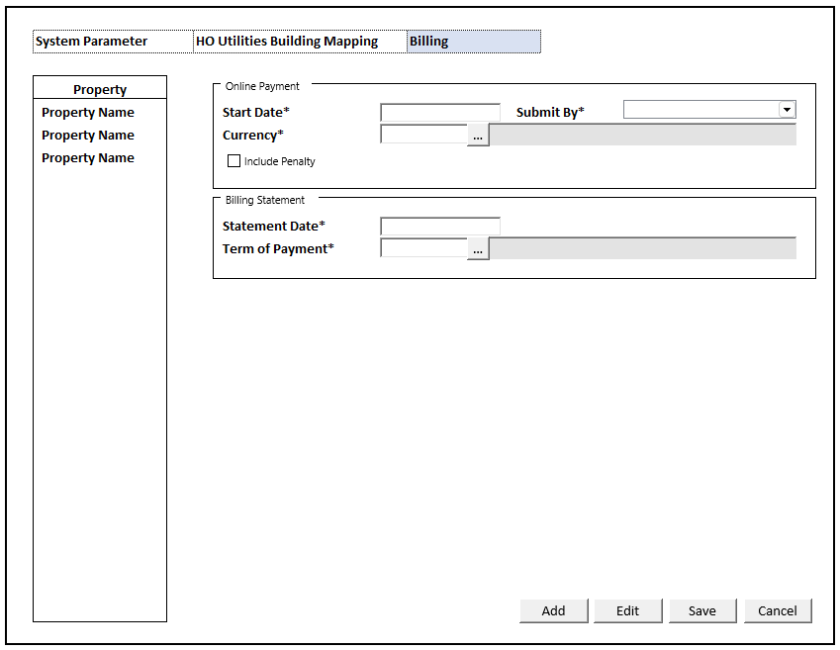

### BUTTON DEFINITION

|  |  |  |
| --- | --- | --- |
| **Button Name** | **Action** | **Enabled** |
| Add | Jalankan ADD PROCESS | * NOT on CRUD Mode * VAR_SYSTEM_PARAM is null |
| Edit | Jalankan EDIT PROCESS | * NOT on CRUD Mode * VAR_SYSTEM_PARAM is null |
| Save | Jalankan SAVE & VALIDATION PROCESS | * On CRUD Mode |
| Cancel | Jalankan DISPLAY PROCESS | * On CRUD Mode |

### ROLES

|  |  |
| --- | --- |
|  | **Test** |
| * User yg punya akses ke program |  |

### INITIAL PROCESS

|  |  |
| --- | --- |
|  | **Test** |
| Set **VAR_TAB_ID** = ‘02’   * **Load Property List**   Jalankan RSP_GS_GET_PROPERTY_LIST dengan parameter, simpan hasil ke VAR_PROPERTY_LIST dan VAR_SELECTED_PROPERTY   * + VAR_COMPANY_ID   + VAR_USER_ID * **Get Payment Submit By**   Jalankan RSP_GS_GET_GSB_CODE_LIST dengan parameter, simpan hasil ke VAR_PAYMENT_SUBMIT_BY   * + ‘BIMASAKTI’   + VAR_COMPANY_ID   + ‘_PM_PAYMENT_SUBMIT_BY’   + VAR_LANG_ID * **Load System Parameter**   Jalankan RSP_PM_GET_SYSTEM_PARAMETER_DETAIL dengan parameter, simpan hasil ke VAR_SYSTEM_PARAM   * + VAR_COMPANY_ID   + VAR_SELECTED_PROPERTY.CPROPERTY_ID   + VAR_USER_ID   + VAR_TAB_ID |  |

### DISPLAY PROCESS

#### FIELD DEFINITION

|  |  |  |  |
| --- | --- | --- | --- |
| **Name** | **Field** | **Type** | **Validation** |
| **Billing Form** |  | **Data:** FORM_DATA |  |
| **Online Payment Group Box** |  |  |  |
| Flag Online Payment | LENABLED_ONLINE_PAYMENT | Hidden | Default Value = TRUE |
| Start Date* | COL_PAY_START_DATE  Convert to DOL_PAY_START_DATE from “YYYYMMDD” format | DatePicker, Disabled, Required | Enabled:  on ADD & EDIT  LENABLED_ONLINE_PAYMENT = TRUE |
| Submit By* | COL_PAY_SUBMIT_BY | Combobox, Disabled, Required  Isi combobox dengan VAR_PAYMENT_SUBMIT_BY  Set ValueField = CCODE  Set TextField = CNAME | Enabled:  on ADD & EDIT |
| Currency* | COL_PAY_CURRENCY | Textbox, Disabled, Required | Enabled:  on ADD & EDIT  LENABLED_ONLINE_PAYMENT = TRUE  On Lost Focus  Go to 🡪 CURRENCY LOOKUP PROCESS  On value change, update:  COL_PAY_CURRENCY, COL_PAY_CURRENCY_DESCRIPTION |
|  |  | Lookup, Disabled | Enabled:  on ADD & EDIT  LENABLED_ONLINE_PAYMENT = TRUE  On Lookup Button clicked:  Go to 🡪 CURRENCY LOOKUP PROCESS  On value change, update:  COL_PAY_CURRENCY, COL_PAY_CURRENCY_DESCRIPTION |
|  | COL_PAY_CURRENCY_DESCRIPTION | Textbox, Disabled |  |
| Include Penalty | LOL_PAY_INCL_PENALTY | Checkbox, Disabled | Enabled:  on ADD & EDIT  LENABLED_ONLINE_PAYMENT = TRUE |
| Billing Statement Group Box |  |  |  |
| Statement Date* | CBILLING_STATEMENT_DATE | NumericTextbox, Disabled, Required | Enabled:  on ADD & EDIT  Min Value = 1  Max Value = 31 |
| Term of Payment* | CBILLING_STATEMENT_TOP_CODE | Textbox, Disabled, Required | Enabled:  on ADD & EDIT  On Lost Focus  Go to 🡪 PAYMENT TERM LOOKUP PROCESS  On value change, update:  CBILLING_STATEMENT_TOP_CODE, CBILLING_STATEMENT_TOP_NAME |
|  |  | Lookup, Disabled | Enabled:  on ADD & EDIT  On Lookup Button clicked:  Go to 🡪 PAYMENT TERM LOOKUP PROCESS  On value change, update:  CBILLING_STATEMENT_TOP_CODE, CBILLING_STATEMENT_TOP_NAME |
|  | CBILLING_STATEMENT_TOP_NAME | Textbox, Disabled |  |

#### GRID DEFINITION

|  |  |  |  |
| --- | --- | --- | --- |
| **Name** | **Field** | **Type** | **Validation** |
| **Property Grid** |  | **Data:** VAR_PROPERTY_LIST  **Type:** Navigator | Allow: -  View Only  On Selected Changed,  Set **VAR_SELECTED_PROPERTY** = Selected Row’s Data  **Load System Parameter** Jalankan RSP_PM_GET_SYSTEM_PARAMETER_DETAIL dengan parameter, simpan hasil ke VAR_CARE_LIST dan VAR_SELECTED_CARE:   * + VAR_COMPANY_ID   + VAR_SELECTED_PROPERTY.CPROPERTY_ID   + VAR_USER_ID   + VAR_TAB_ID |
| Property | CPROPERTY_NAME | Textbox |  |

### CURRENCY LOOKUP PROCESS

#### ON LOST FOCUS

##### PARAMETER

|  |  |
| --- | --- |
| **Parameter Name** | **Description** |
| CCOMPANY_ID | VAR_COMPANY_ID |
| CUSER_ID | VAR_USER_ID |
| CSEARCH_TEXT | FORM_DATA.COL_PAY_CURRENCY |

##### ACTION

|  |
| --- |
|  |
| * Run **GSL00300 – Currency Lookup** dengan parameter:   + CCOMPANY_ID   + CUSER_ID   + CSEARCH_TEXT * Set **FORM_DATA**   COL_PAY_CURRENCY = LOOKUP_RETURN_VALUE.CCURRENCY_CODE  COL_PAY_CURRENCY_DESCRIPTION = LOOKUP_RETURN_VALUE.CCURRENCY_NAME |
|  |

#### BEFORE OPEN LOOKUP

##### PARAMETER

|  |  |
| --- | --- |
| **Parameter Name** | **Description** |
| CCOMPANY_ID | VAR_COMPANY_ID |
| CUSER_ID | VAR_USER_ID |
| CSEARCH_TEXT | ‘’ |

##### ACTION

|  |
| --- |
|  |
| * Run **GSL00300 – Currency Lookup** dengan parameter:   + CCOMPANY_ID   + CUSER_ID   + CSEARCH_TEXT |
|  |

#### AFTER OPEN LOOKUP

##### CANCEL PROCESS

###### ACTION

|  |
| --- |
|  |
| * Close this lookup |
|  |

##### LOOKUP SELECT DATA PROCESS

###### ACTION

|  |
| --- |
|  |
| * Close this lookup * Set **FORM_DATA**   COL_PAY_CURRENCY = LOOKUP_RETURN_VALUE.CCURRENCY_CODE  COL_PAY_CURRENCY_DESCRIPTION = LOOKUP_RETURN_VALUE.CCURRENCY_NAME |
|  |

### PAYMENT TERM LOOKUP PROCESS

#### ON LOST FOCUS

##### PARAMETER

|  |  |
| --- | --- |
| **Parameter Name** | **Description** |
| CSEARCH_TEXT | Term of Payment Field’s Value |

##### ACTION

|  |
| --- |
|  |
| * Run **GSL02100 – Payment Term Lookup** dengan parameter:   + CSEARCH_TEXT * Billing Form stay on CRUD MODE * Set **FORM_DATA**   CBILLING_STATEMENT_TOP_CODE = LOOKUP_RETURN_VALUE.CPAY_TERM_CODE  CBILLING_STATEMENT_TOP_NAME = LOOKUP_RETURN_VALUE.CPAY_TERM_NAME |
|  |

#### BEFORE OPEN LOOKUP

##### PARAMETER

|  |  |
| --- | --- |
| **Parameter Name** | **Description** |
| CSEARCH_TEXT | ‘’ |
|  |  |

##### ACTION

|  |
| --- |
|  |
| * Run **GSL02100 – Payment Term Lookup** dengan parameter:   + CSEARCH_TEXT |
|  |

#### AFTER OPEN LOOKUP

##### CANCEL PROCESS

###### ACTION

|  |
| --- |
|  |
| * Close this POPUP * Billing Form stay on CRUD MODE |
|  |

##### LOOKUP SELECT DATA PROCESS

###### ACTION

|  |
| --- |
|  |
| * Close lookup * Billing Form stay on CRUD MODE * Set **FORM_DATA**   CBILLING_STATEMENT_TOP_CODE = LOOKUP_RETURN_VALUE.CPAY_TERM_CODE  CBILLING_STATEMENT_TOP_NAME = LOOKUP_RETURN_VALUE.CPAY_TERM_NAME |
|  |

### ADD NEW PROCESS

#### ACTION

|  |
| --- |
|  |
| * Set **VAR_SAVE_MODE** = ‘ADD’ * Enabled Fields: ‘Start Date’, ‘Submit By’, ‘Currency’, ‘Currency Lookup Button’, ‘Statement Date’, ‘Term of Payment’ * Set focus to column: ‘Start Date’ |
| * Proses:   + ‘Save’ 🡪 Go To SAVE & VALIDATION PROCESS   + ‘Cancel’ 🡪 Go To DISPLAY PROCESS |

### EDIT PROCESS

#### ACTION

|  |
| --- |
|  |
| * Set **VAR_SAVE_MODE** = ‘EDIT’ * Set **FORM_DATA**: VAR_SYSTEM_PARAM * Enabled Fields: ‘Start Date’, ‘Submit By’, ‘Currency’, ‘Currency Lookup Button’, ‘Statement Date’, ‘Term of Payment’ * Set focus to column: ‘Start Date’ |
| * Proses:   + ‘Save’ 🡪 Go To SAVE & VALIDATION PROCESS   + ‘Cancel’ 🡪 Go To DISPLAY PROCESS |

### SAVE & VALIDATION PROCESS

#### VALIDATION

|  |  |  |
| --- | --- | --- |
| **Field** | **Condition** | **Validation Message** |
| Start Date | Empty | Please fill Start Date! |
| Submit By | Empty | Please choose Submit By! |
| Currency | Empty | Please fill Currency! |
| Statement Date | Empty | Please fill Statement Date! |
| Term of Payment | Empty | Please fill Term of Payment! |

#### ACTION

|  |
| --- |
|  |
| * **Validate** (See VALIDATION table)   IF Success, jalankan Save System Param  IF Failed, stay on Add/Edit Process   * **Save System Param**   Jalankan RSP_PM_MAINTAIN_BILLING_PARAMETER dengan parameter,  @CCOMPANY_ID = VAR_COMPANY_ID  @CPROPERTY_ID = VAR_SELECTED_PROPERTY.CPROPERTY_ID  @COL_PAY_START_DATE = FORM_DATA.COL_PAY_START_DATE  @COL_PAY_SUBMIT_BY = FORM_DATA.COL_PAY_SUBMIT_BY  @COL_PAY_CURRENCY = FORM_DATA.COL_PAY_CURRENCY  @LOL_PAY_INCL_PENALTY = FORM_DATA.LOL_PAY_INCL_PENALTY  @CBILLING_STATEMENT_DATE = FORM_DATA.CBILLING_STATEMENT_DATE  @CBILLING_STATEMENT_TOP_CODE = FORM_DATA.CBILLING_STATEMENT_TOP_CODE  @CACTION = VAR_SAVE_MODE  @CUSER_ID = VAR_USER_ID |
| * Go to DISPLAY PROCESS |

# CR LIST

|  |  |  |
| --- | --- | --- |
| **CR** | **Description** | **Notes** |
| CR01  NS, 25 Nov 2024 | * Menambahkan GL Link * Menambahkan Generate Invoice Process * Menambahkan Utilities Charges and Tax * Menambahkan Group Box Handover * Menambahkan Update By, Update Date, Create By, Create Date di Tab System Parameter * Menambahkan Tab “HO Utilities Building Mapping” | DROPPED RSP_PM_GET_SYSTEM_PARAMETER_LIST |
| CR02  NS, 20 Jan 2025 | * Menambahkan Tab Billing |  |
| CR03  NS, 03 Feb 2025 | * Menambahkan Parameter untuk Chiller |  |